A GREAT
MARKETING PLAN
IS WHAT IT TAKES TO
SELL YOUR HOME
TOP DOLLAR IN
TODAY’S MARKET

The longer the home sits on the market, the bigger the discount it needs to sell. The faster you reach all potential buyers, the more money you can get from selling your home. Hit the ground running with this marketing plan to reach buyers at a local, national and even international level. Don’t waste your time and money any longer on tactics that simply do not work.

MARKETING PLAN OVERVIEW:
PROVEN PROCESS
To Locate Buyers and Sell Your Home for MORE Money
Selling a home has become as easy as it has become competitive. As technology becomes more widely available and consumption increases, modern buyers are able to glance at vast open home catalogues in mere seconds. However, staying on top of new emerging real estate trends is useless without covering the essential necessities first. Old-fashioned methods are still extremely effective for the ‘drive-through-the-neighborhood’ buyers. A successful home-selling campaign merges traditional and modern strategies to target both audiences. Here are the most undeniably important ways to stand out from the competition and attract the right buyers for your home:

Copywriting

What is Copywriting? It is the art and science of writing copy (words used on web pages, ads, promotional materials, etc.) that sells your product or service and convinces prospective customers to take action. In many ways, it's like hiring one salesman to reach all of your customers. Most homeowners and Realtors agree that copywriting is an important necessity for selling a home for several reasons. Being able to communicate essential information in an easily understood manner, with detailed explanation, increases the chances of selling a home exponentially. Shining light on certain features may catch the attention of the right buyer. Here is my favorite example of why copywriting is so important.
Did you know that Lexus is made by Toyota? Did you also know that the Toyota Avalon and the Lexus GS are nearly identical vehicles? Both cars are nearly identical. They are both mid-size cars with virtually the same interior/exterior dimensions. Down to the 3.5L V6 engine and the low 30 Highway MPG rate, you would never know why the 2014 Lexus GS is nearly 42% more expensive than the 2014 Toyota Avalon. Well, the answer is quite simple – copy write. A heavy weighted argument to what makes the Lexus so luxurious is its’ extensive marketing campaign based on its’ extensive attention to smallest detail.
In advertisements, Toyota is listed as “A car with the right mix of performance and luxury”, “A radical drive” with “Strong edges and beauty in the details.” The explanation is wonderful, but nothing is mentioned that would make it sound the least bit luxurious. Just oppose this with Lexus’ campaign, “Sharp handling, generous standard features and an impeccably crafted cabin.” With “Performance that invigorates”, it is no wonder why the Lexus GS campaign is “Not Just Exhilaration. Domination.”
Beyond the quality, Lexus also has significantly more text heavy magazine advertisements than Toyota. The reason being is to really sell the features of the car. It’s this understanding of the importance of copy write that will not only make you sell a home for more money, but much faster as well. Would you rather be driving a Toyota or a Lexus? How would you rather sell your home as the Toyota or the Lexus? Remember the biggest difference is the price.
Photography
A good photograph has a significantly higher probability of selling a home than a bad or even mediocre image. In fact, there’s a 139% increase in clicks when the photograph is visually attractive. When 89% of home buyers search online for a home, you really want to make sure pictures of your home stand out and portray it in the best light.
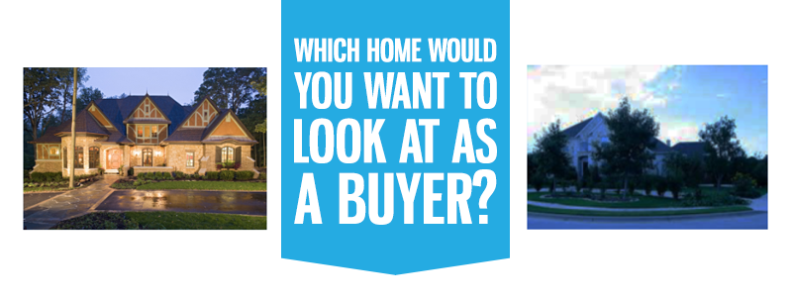
Presenting Your Home
Your home will be photographed from both the exterior and interior. You want to make sure you show the best value and features in your home. Sometimes, staging may be recommended or even necessary. Staged homes on average tend to spend 2 months less in the market than un-staged homes. In mortgage payments alone, the seller can easily save well over $2,000.
The point is to make the place look fresh and clean, and feel like home, connotatively speaking, as best as possible. This is a sure way to get buyers to submit offers quickly. More offers means a better choice to get the most money at a much faster rate.

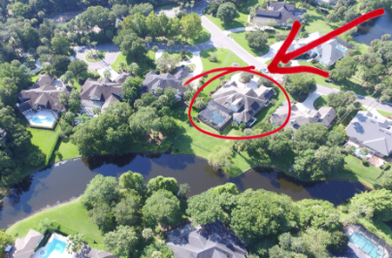
Aerial photography is the most impressive photography to obtain of any home. Angles that seem impossible to reach show the high value of the home. Instead of just taking any photo of the front of your house, you spent time and money to get virtually cinematic pictures of your home, making it seem more suitable to a buyer’s dream home. Don’t fail to go above and beyond. Photography drones were legalized in the world of real estate photography in early 2015, making them a ‘cutting-edge’ technology. Many drones can be purchased at a fairly low price. Drone photography is a great tool that should be utilized before it becomes the real estate industry norm.

Videos and Virtual Tours

The best way not to waste time doing constant walkthroughs is to use Videos and Virtual Tours. With multiple video hosting sites now available (YouTube, Google, AOL, Y!, Vimeo, Dailymotion, etc.), you have more chances of being found. Beyond that, buyers downright prefer having videos and virtual tours. According to ComSource, “Consumers/clients spend an average of 75% longer on websites with a video.” This, along with a detailed description, can increase the likelihood of selling. Dr. McQuivey of Forrester Research also claims that “Watching 1 minute of video is the equivalent to reading 1.8 million words.” Don’t miss this enormous opportunity to sell your home!

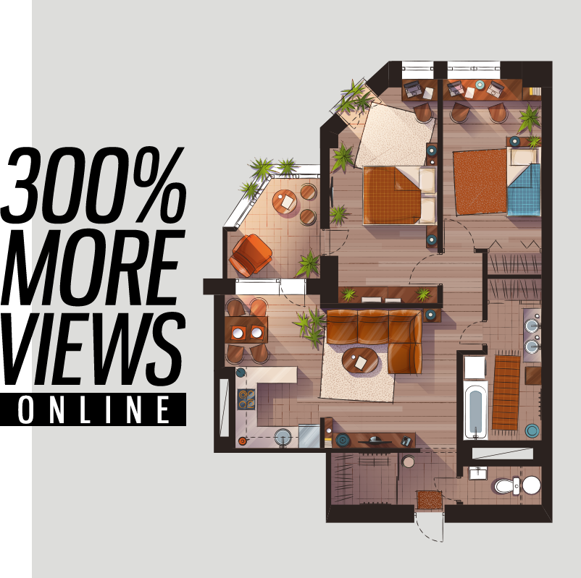
If words alone don’t help buyers visualize the home, and videos don’t provide the details they want, then the floor plan is the ultimate game-changer. Not only does it provide an elaborately detailed view of the home, but by adding color and illustrations of potential furniture arrangements, buyers can truly envision your home as the perfect place to settle in. Any way you can prove to buyers your home is perfect for them will only increase the value and help decrease the amount of time it takes to sell.
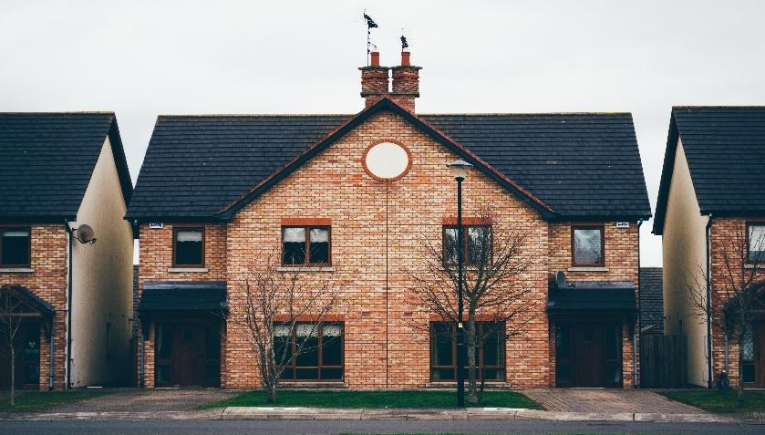
Single Property Website
To really increase your chances of being found, single property websites should be the hub of all directed traffic for the house you are selling. Make sure to include all of the following information, if available (information mainly consists of the topics previously discussed): Video, Virtual Tour, Floor Plan, Copywriting, Pictures, Local Schools, and Maps Drone Videos, and Much More. Everything you can do to showcase your home will only increase your ability to sell the home more quickly and for more money.

Online Marketing
(Local, National, and Worldwide)

We previously skimmed over the fact that 89% of home buyers search online to buy a home, but now, we’ll dive into it. If there are 1,000 buyers in your community, then 890 people have been searching online. That number is outrageous. After solidifying your copy and photography, an essential step in the process of generating more money fast is to effectively use the internet. Listings can find a spot in over 900 websites online. From MLS to Zillow, it’s imperative that sellers optimize their content (copywriting and photography, as mentioned previously).

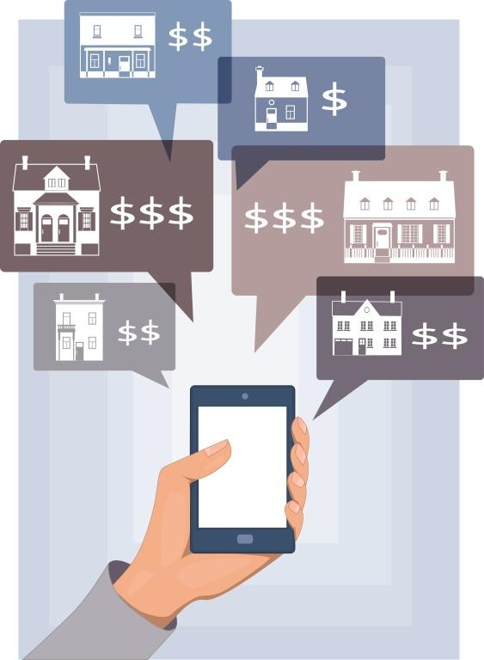
Online Targeted Marketing
Tired of attracting the wrong people to view your home? Targeted marketing is the best solution to only draw attention from serious buyers. However, Online Targeted Marketing is tricky because it involves a detailed understanding of connecting with social circles, targeting behaviors, ad spending, blogging, partnering up and being relevant in the community. However, it is the most effective way to reach the 89% of buyers searching for homes online. Here are some numbers to put its importance into perspective.
Since 2008, the Facebook community has grown in population by 49%. As of today, 73% of Americans have social network profiles, which adds up to a number above 220,000,000 people. 293,000,000 Americans also use Google. Out of those, 91.5% only view the first page of results, which means that less than 10% of the population actually advances to the second page — confirming once again that you must have your home on the forefront of ALL searches.

Retargeting

Never lose a potential buyer again. Retargeting campaigns are the ultimate way to bring back potential buyers who have once shown an interest in your property. Have you ever been online, viewed something you were interested in and decided not to buy? Only to later find ads, along other web pages, displaying that product again? If so, you have been the subject of a successful retargeting campaign.
Retargeting installs a ‘cookie’ on any customer who visits your content site. This cookie is what allows someone to advertise their home on other sites with the intent of bringing back the buyer to make an offer. In just 4 weeks, retargeting exposure can increase site visitation by over 700%. This will bring buyers who are viewing other homes in the area to your single property site.

SEO
Search Engine Optimization will bring your content to the top of the first page in Google and help you stand out. Knowing how to effectively write copy can add keywords that most people search for online. Keyword search is the biggest traffic driver to content sites, beating social media by over 300%. Also, SEO leads have nearly a 15% close rate, which is extremely effective. That means that about 1 out of 7 viewers who are also potential buyers could be the next purchaser of your home.

Signs
The easiest way to be identified by potential buyers driving down the neighborhood is from the traditional sign on the front yard. The red for sale sign is the end goal that buyers seek on long drives through neighborhoods they want to settle down in. Having detailed and correct information at the time potential buyers cruise through is absolutely crucial. Including a sign rider with a hotline for calls or text is the equivalent of a personal open house tour, available 24/7. To gather the best information to add to the sign rider to attract buyers, continue reading through these tips.
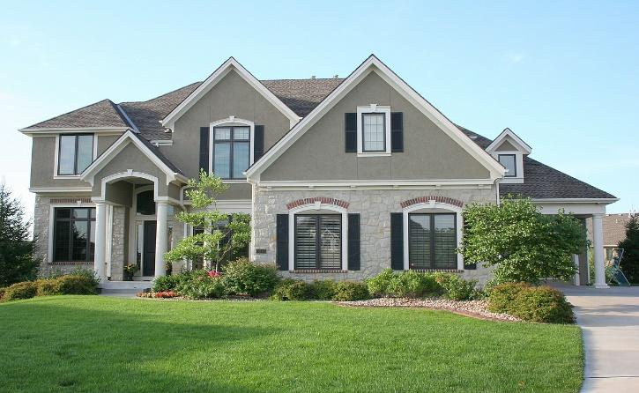
Direct Mail
A great strategy to find the right buyers depends upon which media they rely most heavily. To weed out cheap buyers, direct mail is the best strategy for maximizing a credible reach. There is a 300% increase in response between people who make less than $100k/per year and those who make more than $100k/per year. Choosing an area is easy with a little bit of research, and sending a larger quantity of mail improves your chances of selling.
Postcards are great for mailing because they attract a reader’s attention and are more personalized. They are especially useful for homes that just listed, and they can help increase local awareness of properties on the market to those who are interested or know of someone who is.

Brochure
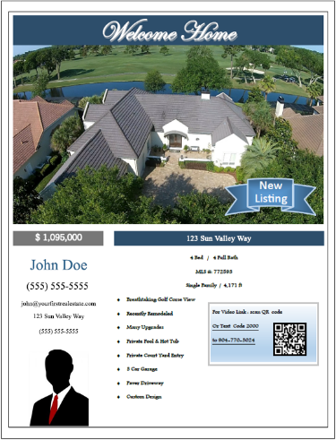
Brochures are useful tools for the “let-me-think-about-it” buyer. Brochures have a long shelf life, which can slowly convince an interested prospect to buy. They should provide all the information that a buyer may ask, including links to websites for more content (including pictures), as well as contact information for when they are ready to make the decision. Copywriting for a brochure must be as long as it should be descriptive.

Taking all this information and pushing it to OVER 917 websites.

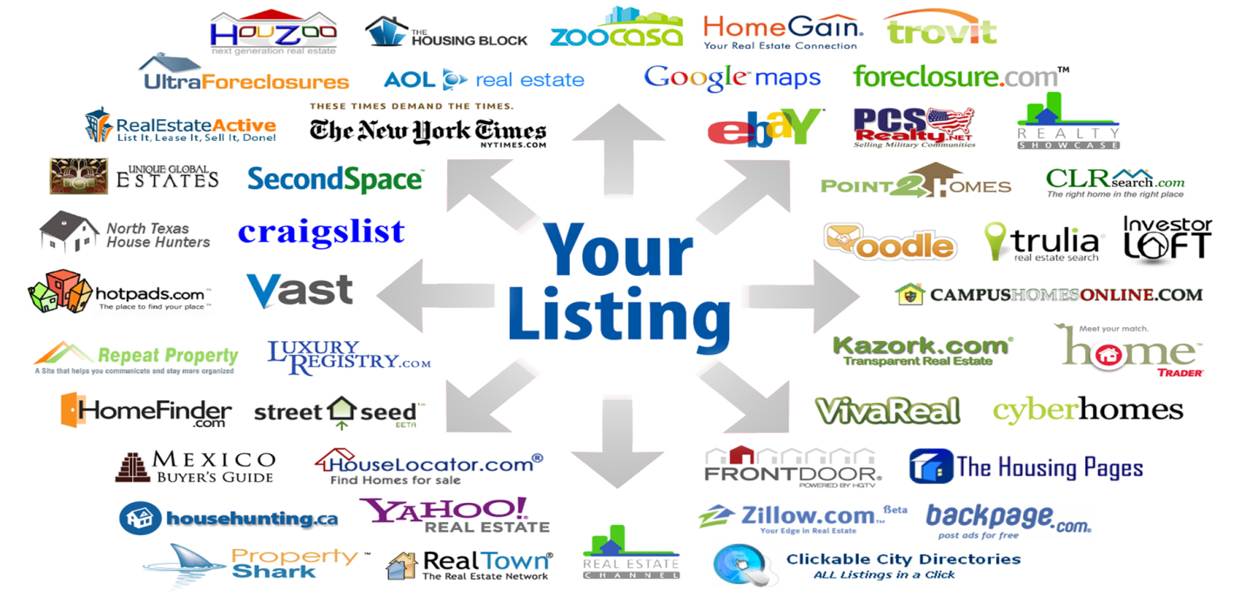
Our Marketing Plan Get Homes SOLD! For MORE MONEY.
PUT ALL THE ATTENTION ON YOUR HOME
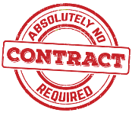
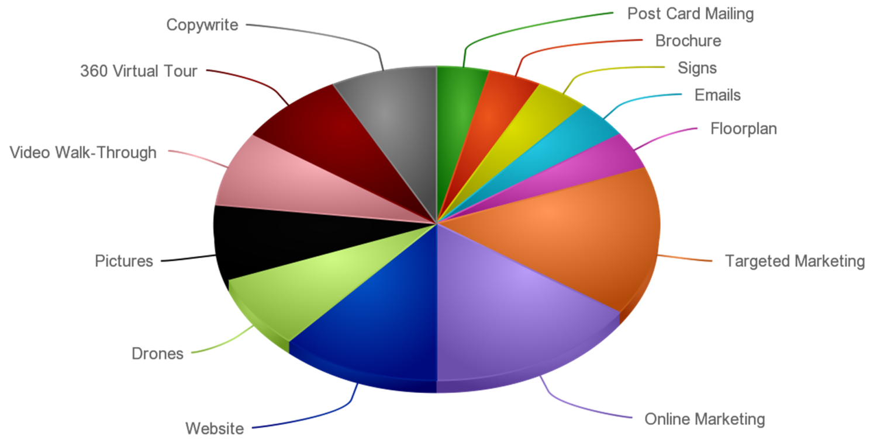

Traditional
Marking

Our 69 Point
Marking
Call Now to go over how I can help you, my cell is (904) 555-1212

MORE BUYERS
Get You MORE OFFERS
AND
MORE MONEY

Know the difference !
Our Pledge:
1. Our team will always represent your best interests.
2. Our team will keep in touch with you on a regular basis at least twice a week.
3. Our team will do everything within reason to get your home SOLD as quickly and efficiently as possible.
4. Our team will treat your money like our own and strive to get highest possible price for your property.
All of us here at You First Real Estate are a TEAM, and that give us the ability to deliver the most cutting edge marketing system in today’s market. Whether you talk to all of us or just one member of our team, we are ALL working everyday to sell your home for more money fast.
We love what we do, and look forward to add you to our list of SATISFIED clients.
Regards,

69 STEP Marketing the Property Process:
1. A “FOR SALE” sign will be placed prominently on your property.
2. Text property information rider will be added to “FOR SALE” sign.
3. A “lockbox” will be installed on the property to facilitate the showing process.
4. Our professional photographer will be ordered to take interior/exterior photos.
5. Our professional videographer will be ordered to take interior/exterior video, including aerial.
6. Your home will be promptly submitted to the local Multiple Listing Service (MLS). The remarks section will be customized to maximize the appeal to cooperating agents, and a maximum of 30 photos will be posted.
7. Professional copy writer will write sales copy for your property.
8. You will be emailed a copy of your MLS listing for review.
9. A high-quality Marketing Brochure will be prepared by our full production Marketing Department, highlighting the features and benefits of your home for cooperating agents and potential buyers.
10. Listing placed on our premiere webpage-links created through network of OVER 1,000 websites.
11. Launch social media Facebook campaign, with an additional campaign launched each week.
12. Launch video campaign on all major video sites.
13. Launch SEO campaign directing traffic to your single-property site.
14. Launch retargeting campaign for your single property website and to buyers searching online.
15. Enlist the help of our own network of clients and colleagues by emailing them a special flyer describing your home and asking if they know of possible buyers.
16. Send email “Just Listed” to seller for distribution to their friends and family.
17. Send out email to our list of buyers that are currently looking for a home.
18. Check with our relocation department for buyers transferring to this area.
19. Create web commercial on YouTube for marketing and publish on websites.
20. Add Listing information to specialty internet websites such as Realtor.com, Trulia, Craigslist, Homes.com, Zillow, Home seekers, etc.
21. Modify Realtor.com and associated websites with additional photos and marketing information for maximum exposure.
22. Prepare direct mail “Just Listed” announcements for neighborhood and selected target areas.
23. Coordinate with seller(s)/tenant(s) for area Broker Preview. This is an “open house” for other realtors to view the home for their potential clients.
24. Coordinate Broker Preview advertising for MLS “White Sheet.”
25. Quality full color flyers will be delivered within 48 hours of photo shoot.
26. Distribute E-Flyer to ALL Realty Offices and Agents.
27. Send E-Flyer of the information sheet on your home to other REALTORS for a specific geographic region-minimum of 3,000 agents.
28. Email agents that have Listed or Sold properties in the Area/Tract for last 6 months to notify of new listing and for agents to solicit late buyers.
29. Promote your property at the appropriate Association(s) of Realtors® Breakfast for maximum exposure to other cooperating agents. Color brochures will be distributed to attendees.
30. Seller contacted after preview and associates’ comments discussed.
31. Create Listing Activity/Agent Showing Services Report.
32. Create real estate “Activity Website” to alert seller of current real estate activity in area.
33. Hold 1st Mega Open House. Solicit feedback from prospects and other realtors to obtain information, which may improve the chances of selling your home.
34. Coordinate Open House schedule with Seller for the next 60 days (if applicable).
35. Set up Personal Listing Activity Website for Seller(s), including passwords to access information on what marketing and showing activity has happened on property.
36. Upload Lock Box Daily Activity Report. Call Agents for Preview/Showing Feedback. Update Services Report (on-going).
37. Qualify ALL incoming leads-log in Services Report to update Seller (on-going).
38. Copies of ads emailed to client.
39. Call ALL agents for additional Feedback/Client Status changes since visiting the property (Mondays and Fridays).
40. Analyze weekly Tract/Area Real Estate Activity and discuss Market Trends with Seller (Mondays).
41. Call Seller to give results on ALL Showing Activity and Share Feedback-Email updated Services Report (Fridays).
42. Send Market Time Report to Sellers (Bi-Monthly).
43. Download website hits for the week and forward to Seller (Mondays).
44. Remind client of Personal Website for Listing Updates.
46. Replenish flyers (ongoing).
47. Hold open houses when appropriate.
48. Face-to-face with Seller Marketing and Pricing Strategy Review Meeting (Monthly).

Negotiating the Contract:
49. Qualify buyer through preferred lender and obtain supporting financial documents to verify the buyer’s sincerity and financial situation.
50. Before you sign, we will review the contract and your obligations — counter offer if necessary.
51. The team will explain how contingencies and release clauses work.
52. Provisions will be put in place to protect you from signing a “blank check” for problems or repairs.
53. The team will make sure you do not sell your home to more than one buyer.
54. Your legal disclosure requirements will be explained, and the team will review the Real Estate Transfer Disclosure Statement with you.
55. The ramifications of pest control inspections/reports will be explained and general structural inspections/reports.
56. The “Liquidated Damages” clause will be explained, and the team will give you a written “Arbitration” clause explanation.
57. Explanation of your responsibilities regarding the condition of the property will be discussed.
58. An estimation of your net proceeds will be calculated based on a specific offer.
60. Advice will be given to help you handle the issue of “possession.”
Managing and Closing Escrow:
61. The team will follow up closely on the progress of the buyer’s loan and coordinate the payoff of your existing loan.
62. The team will facilitate the appraisal process.
63. The team will stay in constant communication with the buyer’s agent to ensure a smooth escrow (Mondays and Fridays).
64. The team will advise you regarding specific buyer requests related to structural pest control and general structural inspections.
65. The team will closely monitor contingency removal dates and discuss these with you.
66. The team will coordinate the details of the transaction with the escrow officer.
67. The team will help you if conflicts or impasses with the buyer arise.
68. The team will be with you at the escrow company when you sign your escrow instructions.
69. The team will make sure you get your check and settlement documents promptly after closing.
You will become one of my many satisfied clients.
Call my cell:
904-555-1212

